Supplementary Information for:
Challenges on Optical Printing of Colloidal Nanoparticles
Ianina L. Violi, ^{1,2} * Luciana Martínez, ¹ Mariano Barella, ¹ Cecilia Zaza, ^{1,3} Lukáš Chvátal,⁴ Pavel Zemánek,⁴ Marina V. Gutiérrez,⁵ María Y. Paredes, ⁵ Alberto F. Scarpettini,⁵ Jorge Olmos-Trigo, ⁶ Valeria R. Pais, ³ Iván Díaz Nóblega,³ Emiliano Cortes,⁷ Juan José Sáenz, ⁶ Andrea V. Bragas,³ Julián Gargiulo,^{1, 7}*and Fernando D. Stefani^{1,3*}

1. Centro de Investigaciones en Bionanociencias (CIBION), Consejo Nacional de Investigaciones Científicas y Técnicas (CONICET), Godoy Cruz 2390, CABA, Argentina
2. Instituto de Nanosistemas, UNSAM-CONICET, Av. 25 de Mayo 1021, San Martín 1650, Argentina.
3. Departamento de Física, Facultad de Ciencias Exactas y Naturales, Universidad de Buenos Aires, Güiraldes 2620, CABA, Argentina
4. Institute of Scientific Instruments of the Czech Academy of Sciences, v.v.i., Czech Academy of Sciences, Královopolská 147, 612 64 Brno, Czech Republic
5. Grupo de Fotónica Aplicada, Facultad Regional Delta, Universidad Tecnológica Nacional, 2804 Campana, Argentina
6. Donostia International Physics Center (DIPC), Donostia-San Sebastián, País Vasco, España
7. Chair in Hybrid Nanosystems, Nanoinstitute Munich, Faculty of Physics, Ludwig-Maximilians-Universität München, 80799 München, Germany
INDEX
S1. Aging of printed NPs arrays 2
S2. Extinction spectra of Ag and Au NPs 3
S3. Calculations of optical forces 3
S4. Power dependance of selectivity in the printing of Si NPs 5
S5. Reshaping of optically printed Au NRs 5
S6. SiO₂@Au core-shell single particle scattering spectra 6
S7. SiO₂@Au core-shell Q_{pr} and Q_{abs} 7
REFERENCES 7

S1. Aging of printed NPs arrays
A very important thing to consider when analyzing the applicability and extent of a new method for generating nanoparticle arrays is the stability over time of the prepared samples, as well as their mechanical stability when transferring them to different laboratories. In the case of optical printing, the main concern is that the NPs detach from the substrate over time or due to the motion of the samples. When the COVID-19 pandemic forced us to stay home, many samples were left at the lab for more than a year. To have a brighter view of the stay-home requirement, we took the opportunity to analyze the aging of some of those samples. Figure S1 summarizes the obtained dark-field images of the samples as-prepared, and the same grids aged for different times. As one could conclude by simple inspection of the figures, almost no alteration occurred during times as long as three years. It should be noted that the eldest sample was also analyzed by scanning electron microscopy (SEM) in a different laboratory and then got back, transferring it from an aluminum holder with carbon tape, without any damage. These results show that the optically printed NPs do not age or detach over time.
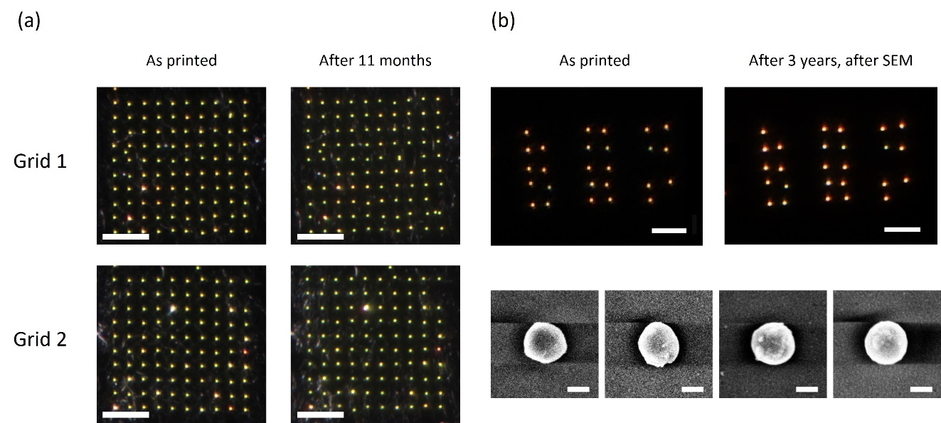
Figure S1. Aging of optically printed grids. (a) Dark-field images of two different 60 nm Au NPs grids printed on-resonance over graphene: as printed and after 11 months at room temperature. Scale-bar: 10 µm. (b) Silicon nanoparticles printed with a 640 nm laser. On the left, the arrangement as they were at the time of printing. The size of the nanoparticles was then measured using SEM. On the right, a dark-field image of the same sample 3 years later. Scale-bar for dark-field images: 10 µm. For SEM images: 100 nm.

S2. Extinction spectra of Ag and Au NPs
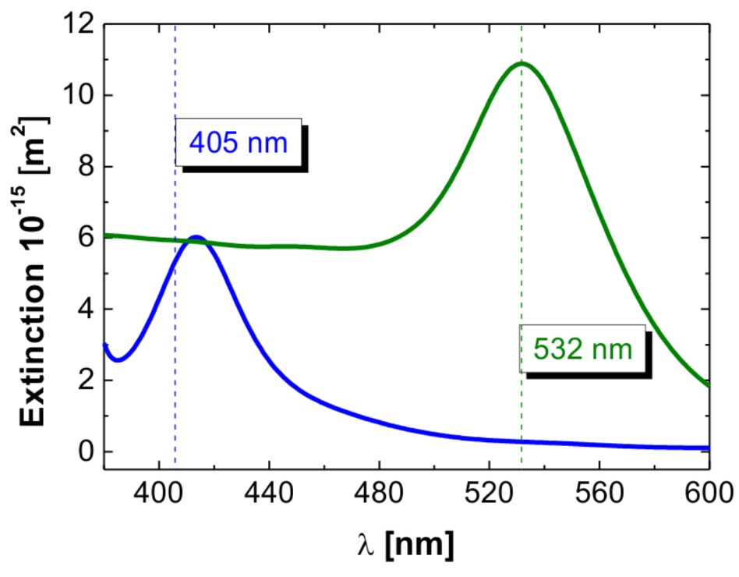
Figure S2. Extinction cross sections calculated using Mie theory for 60 nm Au (green) and Ag (blue) NPs in water. The vertical dashed lines indicate the wavelengths of the lasers used for printing in the experiments discussed in the section “Challenge 2: Lateral resolution”.

S3. Calculations of optical forces
Figure S3 shows the optical force fields in the presence of a fixed particle, using Generalized Lorenz–Mie theory with an extension to multiple spherical particles, as explained in the work by Chvátal et al.¹ First, the force map in the absence of any fixed particle was calculated for Au 60 nm NPs. Figure S3a shows the total optical force field for a Gaussian beam of λ = 532 nm, with a waist of w₀ = 265 nm and power of P = 1.2 mW exerted on a Au 60 nm NP. Grey lines indicate force field lines. Then, the optical force fields in the presence of a fixed particle 200 nm away from the center of the beam were calculated for both polarizations, corresponding to an experimental configuration where it was impossible to print a second particle. Figures 5e and 5f from the main manuscript show the calculated force field for perpendicular and parallel polarization, respectively. In both cases, there are many field lines (trajectories) that end in the substrate. For parallel polarization there are lines that end close to the fixed particle, indicating an attractive interaction between particles. The influence of the fixed particle in the optical field is therefore not strong enough to prevent the second particle from reaching the surface. To better visualize it, the difference between the force fields in the presence and the absence of a fixed sphere is calculated. The resulting subtraction can be interpreted as the distortion of the force field produced by the fixed sphere. This is shown in Figure S3b for perpendicular and S3c for parallel polarization. Oscillations in the sign of the force are typical of optical binding interactions. For both polarizations, the interaction force is at least one order of magnitude weaker than the optical force exerted by the laser beam.
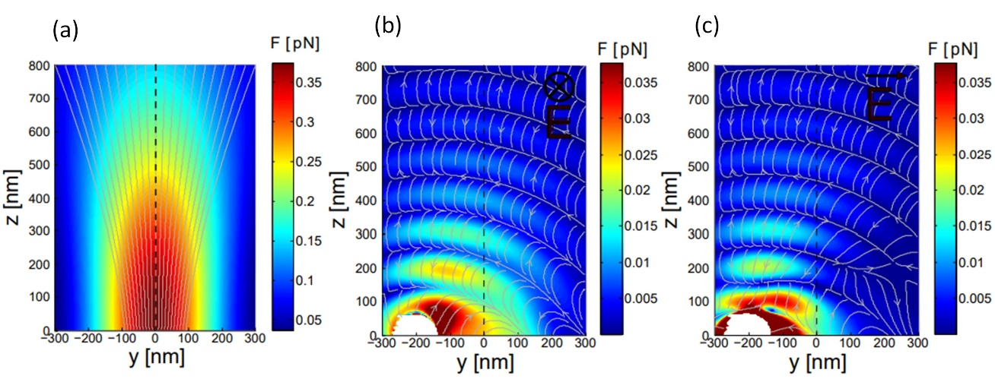
Figure S3. Optical force maps. (a) Total Force in the absence of any fixed particle. (b) Estimation of the forces caused by the fixed particle in a perpendicular polarized beam, obtained by subtracting Fig. 5e and S3a. (c) Estimation of the forces caused by the fixed particle in a parallel polarized beam, obtained by subtracting Fig. 5f and S3a. White areas correspond to inter-penetrated particles and were excluded from the map.

S4. Power dependance of selectivity in the printing of Si NPs
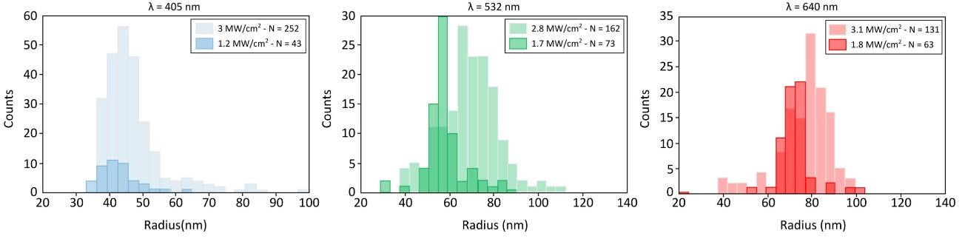
Figure S4. Size distribution of Si NPs printed using 405 nm, 532 nm, and 640 nm lasers for the minimum printing power and a higher power.

S5. Reshaping of optically printed Au NRs
CTAB-capped Au nanorods (Au NRs) were synthesized as reported by Gutiérrez et al.² Printing was performed over fused silica with a highly focused 808 nm laser beam at 6.2 mW/µm² to ensure 100% printing success (lower power leads to a lower success rate).
Dimensions estimated from SEM images: for 133 as prepared Au NRs, their average dimensions were (121 ± 9) nm in length and (27 ± 3) nm in width, meaning an aspect ratio of ~4.4. For 23 optically printed Au NRs, the average dimensions were (86 ± 6) nm in length and (28 ± 4) nm in width (aspect ratio ~3.2).
The temperature increase during printing for a nanorod can be estimated using the theory developed by Baffou et al.³ There, the authors introduce a dimensionless thermal-capacitance coefficient in the temperature increase calculation for arbitrarily shaped NPs. In addition, it is possible to consider the interfacial thermal resistance⁴ of the CTAB coated gold-water surface⁵ taken as 450 MW/m²K. Using the thermal conductivity of water (0.6 W/K.m) and the absorption cross-section at 808 nm (11000 nm²), the temperature increase of a Au NR during printing is ~232 °C.

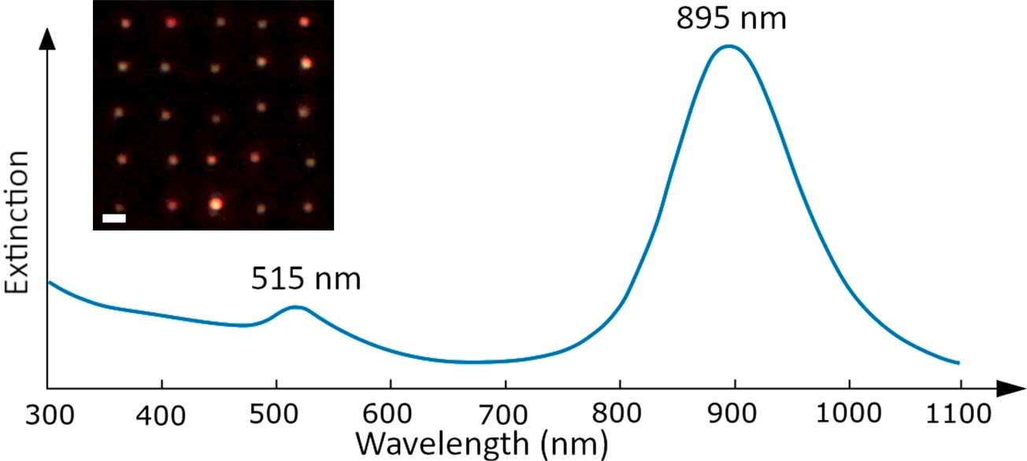
Figure S5: Extinction spectrum of the Au NRs colloid. Longitudinal and transverse plasmon peaks are indicated. Inset: a dark-field image of the optically printed Au NRs in water on a glass substrate with a 640 nm laser beam. Scale bar: 1 um.

S6. SiO₂@Au core-shell single-particle scattering spectra

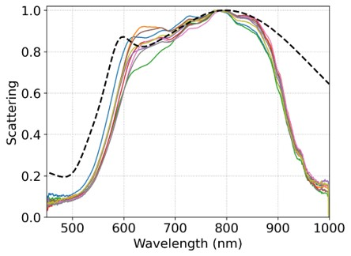
Figure S6: Scattering spectra of nine SiO₂@Au NPs immobilized on glass, in water (solid line) and Mie-simulated spectrum of a 150 nm SiO₂ core/20 nm Au shell NP in water (dashed line). Mean λ_{max} = (787 ± 7) nm. Mean FWHM = (336 ± 6) nm. Mean diameter estimated from SEM images = (193 ± 2) nm.

S7. SiO₂@Au core-shell Q_{pr} and Q_{abs}
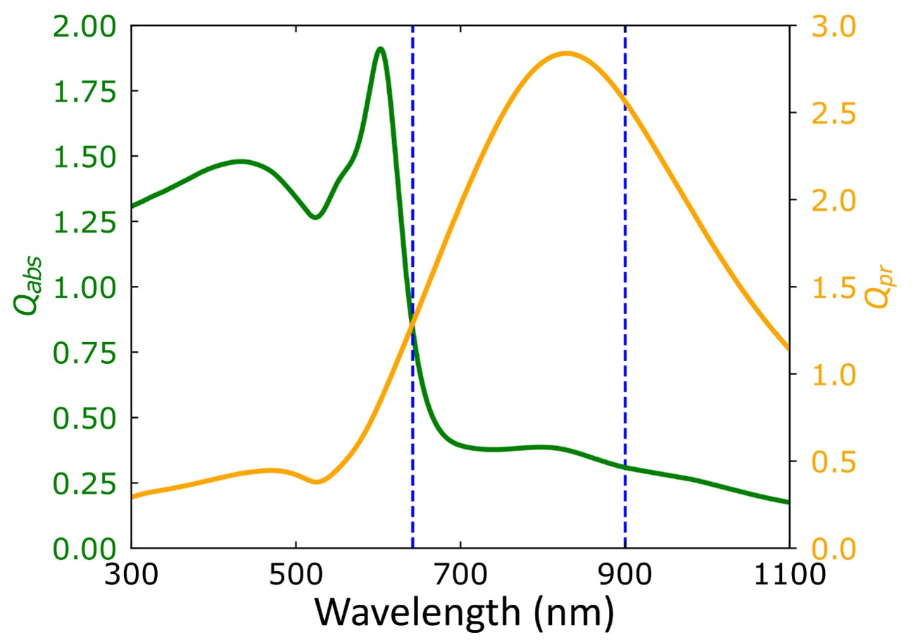
Figure S7: Absorption and radiation pressure efficiency calculated for a core-shell NP in water with a 150 nm diameter silica core and 20 nm gold shell thickness.

REFERENCES

¹ L. Chvátal, O. Brzobohatý, and P. Zemánek, Opt. Rev. 22, 157 (2015).
² M.V. Gutiérrez, M.Y. Paredes, and A.F. Scarpettini, Rev. Mater. 20, 731 (2015).
³ G. Baffou, R. Quidant, and F.J. García De Abajo, ACS Nano 4, 709 (2010).
⁴ G. Baffou and R. Quidant, Laser Photonics Rev. 7, 171 (2013).
⁵ A.J. Schmidt, J.D. Alper, M. Chiesa, G. Chen, S.K. Das, and K. Hamad-Schifferli, J. Phys. Chem. C 112, 13320 (2008).

